|  |
| --- |
| The structure and interaction of silica in plant cell walls |
| Claus Felby  Yohanna Cabrera Orozco |
|  |
|  |
| May 1, 2019 |

Content

Project Development 3

In-vivo study 4

An experimental study on the accumulation of silica in wheat 4

Background and rationale 4

Objective 5

Performed activities 5

Greenhouse experiment to test Si interactions with lignin 5

Greenhouse experiment to test basic Si structures *in-plant* with 29Si isotopic labeling 7

Pending activities 10

Bibliography 11

In vitro study 14

Influence of lignin and lignin model compounds on silicic acid polycondensation 14

Background and rationale 14

Experiments performed 16

Tested solutions 17

Conclusion 18

References 18

# Project Development

The project was granted to study the deposition of silicon in plants. Two main strategies were applied. First, silica deposition was study *in-vitro* to analyze if and how lignin is co-precipitated with silica. Second, silica deposition was study *in-vivo* to see how silica supplementation affect lignin structure. The development and progress of these two strategies are the main content of this report.

The project description included most of the *in-vitro* experiments. But we shifted the project to include the *in-vivo* approach, because we completed and published 1 some of the described tasks earlier than planned. When the project started, we continued the *in-vitro* approach, but the results were inconclusive (as described below), so we focus on the *in-vivo* approach. The *in-vivo* experiments are still under progress.

The results of the project are delayed because Yohanna Cabrera Orozco, who was hired as a postdoctoral researcher for the project, was diagnosed with a progressive neuromuscular disease (Pompe disease) that requires treatment every two weeks at the hospital. For the same reason, a visit to the University of Madison included in the project description was cancelled. Instead, we had/have collaboration with the following labs:

|  |  |  |
| --- | --- | --- |
| Prof. Lars Øgendal. Niels Bohr Institute, University of Copenhagen | Dynamic Light Scattering | Completed |
| Prof. Jan Schjørring. Section for Plant and Soil Sciences, University of Copenhagen | Planning and executing greenhouse experiments; ICP elemental analyses; C/N analyses | Completed |
| Prof. Fleming Larsen. Food science department, University of Copenhagen. | Solid state NMR analysis | Completed |
| Prof. Andres Cabrera. Research Laboratory in Fuels and Energy. National University of Colombia. | Planning and executing GC-MS measurement | In progress |
| Prof. John Ralph and Steven Karlen. Great Lakes Biomass Research Centre. University of Madison. Wisconsin. | Preparation of lignin standards for GC-MS analysis | Completed |

# In-vivo study

# An experimental study on the accumulation of silica in wheat

**Manuscript under preparation**

## Background and rationale

The presence of silicon (Si) in plants contributes to the response of stress-relief mechanisms for environmental events such as drought and pathogen attack. Because of the importance of crops such as wheat, barley, rice, and other grasses that accumulate Si, the understanding of the relationship between this element and plant science is the focus of numerous scientific efforts. Additionally, a new scientific quest is emerging for the study of Si accumulation in grasses: the huge amounts of agricultural waste that these crops generate have to be used in circular economies, but its full potential is hindered by Si presence in the residues.

Silicon is a major soil constituent, therefore plants invariably grow in Si-rich-environments 2. In soil, Si is available in the form of silicic acid solutions. Some plants accumulate so much silicic acid that Si precipitates as silica, e.g., phytoliths. The accumulation occurs mainly in root endodermis, epidermal cells of both leaf and inflorescence bracts 3, as well as awns and leaf macrohairs 4.

The molecular forms of Si that are transported through the xylem are known: only monomers and dimers of silicic acid have been found in the shoots of wheat and rice and no organo-silicon structures have been identified 5. Remarkably, the hemicellulose callose may be templating Si deposition in horsetails (*Equisetum*) 6, and may also play a role in Si deposition of algae and plants in general 7.

Si accumulation seems to be an ancient mechanism because it is present in early divergent plant lineages, and was lost in the course of evolution as silica is less present in later-evolving plants 8. In ancient silica - accumulators such as *Equisetum* species, silica may play a major structural role 9. This structural role was taken later in evolution by lignin. As a general tendency, later-evolving plants have more lignin and less silica 8. Lignin may fulfill a stronger mechanical role because, unlike silica, it can crosslink with cell wall polysaccharides 9.

However, the presence of Si and lignin is not mutually exclusively, and they relationship (if any) unknown. For example, in rice Si deposition starts when the plant cell synthesize and accumulate lignin in the secondary wall 10,11, while Si surplus is positively correlated with lignin content and mechanical strength 12. In *Brachypodium*, Si surplus induces changes in lignin composition 4.

## Objective

The general goal of this work is to shed light on the relationship between the presence, quantity, or chemical structure of lignin and the capacity -or need- of plants to accumulate silica. Particularly, we seek to explore both Si interactions with lignin in wheat (*Triticum aestivum*) and basic Si structures *in-plant* using by laballing the plants with 29 Si isotope and study the chemical structures with solid state NMR. Two experiments were stablished in greenhouse conditions as follows:

## Performed activities

## Greenhouse experiment to test Si interactions with lignin

A greenhouse experiment was set up to compare the effects of Si deficiency and surplus in both total lignin content, lignin monomeric composition, as well as its crosslinking with cell wall polysaccharides, specifically with arabinoxylans –the major hemicelluloses in grass cell walls 13 .

The experimental design was inspired by an article published in 1999 14. In that experiment, four wheat plants were grown in a 100 ml tank containing 0.5 mM Na2SiO3. Si was absorbed by the plants until it was depleted in ca. 80 days. Another set of plants was grown in a Si free environment with the same conditions; as there were not stressors, the Si-free plants grew normally. At day 80, the mature Si-free plants were transferred into a solution containing 0.5 mM Na2SiO3. The mature plants absorbed the same amount of Si in three days, as did plants grown in solutions to which Si had been added during their whole life. The experiment was set-up both in a greenhouse and in a controlled growing chamber yielding the same result: plants deprived from Si avidly absorbed the element at maturity, when all lignin was in place. We wondered if there was any difference in lignin content, quantity, and quality between these treatments. Thus, in our experimental design we included the same treatments: (1) A group grown for 90 days in a solution containing 1.5 mM Na2SiO3; this group was called Si+; (2) a group (Si++) grown without Si until day 85, then 1.5 mM Na2SiO3 added to the tank: (3) a control group without silicon (Si-).

**Nutrient solution**: The rest of the nutrient solution was prepared according to a Standard Operational Procedure of the greenhouse at the University of Copenhagen in Rolighedsvej. In this procedure, commercial fertilizers are mixed in three different 250 L tanks with the formulations in Table 1. Then, an automatized pumping system mixes different ratios of the solutions in the tanks. The solutions are mixed with tap water which contained Si levels of 0.24±0.08 mM SiO2. For the purpose of the experiment, ca.150 L of this nutrient solution was used weekly. The Si content was measured in every occasion with the method described below. Then 1.5 mM Na2SiO3 was added to 50 or 100 L of solution (depending on the time line) from a 30 mM stock solution diluted in dm-water, while the same amount of dm-water was added to the controls. The measured Si content after dilution was between 1.5±0.16 mM. At the end of the week another Si sampling was performed, and the concentrations was always above 0.6 mM, which ensure that there was always Si surplus.

pH was adjusted to 6 using HCl or NaOH solutions.

Table 1. Nutrient solution



**Silicon measurements:** Dissolved silica was measured by heteropoly blue method using the Hach protocol 8186 and a DR/1900 spectrophotometer (HACH Company, Loveland, USA) as described by the manufacturer. A Si standard solution of 1.0 mg/L also from Hach (cat 110649) was used for calibration. Polypropylene volumetric flasks were used for dilution of samples to avoid Si contamination.

**Plant production:** Wheat seeds (JB Asano) were surface sterilized as follows. The seeds were immersed in 2.7% sodium hypochlorite solution (v/v) and a drop of Tween 80 for 30 minutes with constant stirring, then rinsed with MilliQ water five times (10 min each). The seeds were vernalized in the dark at 5°C in MilliQ water for 4 days. Thereafter, the seeds were placed in Si-free oasis horticubes (Smithers-Oasis, Kent, Ohio). The cubes were soaked in 1/10 strength nutrient solution (adjusted to pH 5.5) and excess water drained. Each seed was placed directly into a wet cube. Once seeds started rooted and started to actively grow (4-7 days), they were put it in the cold room for a vernalization period of 50 days.

After vernalization the plants were cultured using the RainForest 72 aeroponic culture system (GHE, Fleurance, France), and placed in a greenhouse, mean temperature 20°C, under 9 h/15 h light (80–100 μE m−2 s−1)/dark regime. (Figure 1).

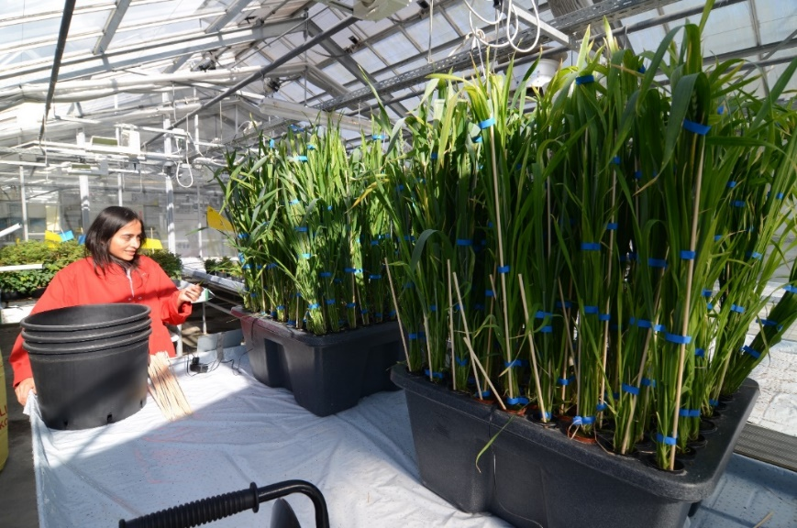

Figure 1. RainForest 72 aeroponic culture system (GHE, Fleurance, France) used to produce wheat plants in a greenhouse.

## Greenhouse experiment to test basic Si structures *in-plant* with 29Si isotopic labeling

A replicate of the previous experiment was set up in low-density polyethylene laboratory bottles (Vitlab, Seeheim, Germany) (Figure 2). Random seedlings were selected and carefully washed with the nutrient solution described above. The plants were put in 1 L bottles containing 600 mL of nutrient solution and aerated with an air pump fitted with an air stone (Oxyboost APR300, AQUAEL, Dubowo, Poland). Hydroponic containers were placed in the same greenhouse as described above. The bottles were wrapped in black plastic and aluminum foil to avoid algae proliferation in the nutrient solution.

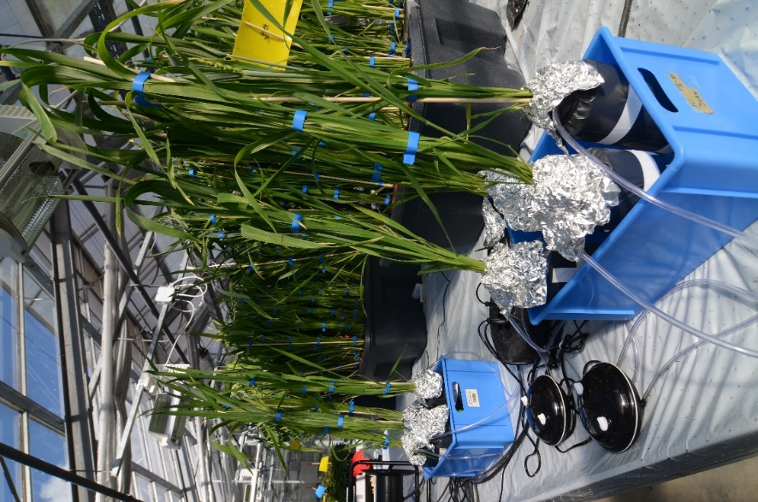

Figure 2. Greenhouse experiment to test basic Si structures in-plant with 29Si isotopic labeling

The nutrient solution was the same as in the previous experiment except by the Si source. A 29Si-enriched solution was prepared using 99.7% 29SiO2 (CortecNet, France). The solutions were made from Milli-Q water. Solutions were kept in polyethylene containers which were kept sealed and refrigerated. Adjustments to pH were made with HCl or NaOH solutions.

The 29Si-enriched solution was prepared in a stainless steel reactor: 0.3 mg 29SiO2 was mixed with 4 g of molten NaOH. NaOH was melted in the reactor, when the temperature reached 500°C, the SiO2 was added and heated 1 h. After cooling to ambient temperature, the solution was diluted to ca. 9 mM Si, the pH was lowered by dropwise addition of HCl to pH ≈ 8 for 2 days (to allow for depolymerization) and then the pH was further lowered to pH 4 and the solution degassed to produce a stable stock solution of monomeric silicic acid 15 . Si concentration was measured using a standard Hach kit (Hach Company, Loveland, CO, USA). A non-enriched SiO2 was also prepared for control plants.

600 mL of nutrient solution was added to each bottle, and the Si content adjusted to 1.5 mM SiO2. In the course of one week, ca. 400 mL of water evaporated and Si absorbed by the plants. Then, the solution was again brought to 600 mL and 1.5 mM SiO2. As the availability of the solution containing 29SiO2 was only 3 liters, it was never changed completely but “regenerated” weekly.

**Sample preparation for further analysis:** Periodically sample plants were harvested, and divided between roots, pods, leaves, flag leaves, and inflorescence bracts according to day of harvesting (Table 2). In 2016, we made the first attempt to perform this experiment. However, the plants did not grow as expected and appeared yellow and not fit. Despite this, we collect the samples to perform some of the analysis and have a secondary data set to test some of the models.

Table 2. Plant parts harvested

|  |  |  |  |  |  |  |  |  |
| --- | --- | --- | --- | --- | --- | --- | --- | --- |
| **Plant Part**  **Day** | **2016** | | | **2017** | | | | **29Si** |
| **50** | **65** | **90** | **60** | **70** | **80** | **90** | **90** |
| Stem | X | X | X | X | X | X | X | X |
| Pods |  |  |  |  |  |  | X | X |
| Flag leaves |  |  |  |  |  |  | X | X |
| Leaves | X | X | X | X | X | X | X | X |
| Inflorescences |  |  |  | X | X | X | X | X |
| Roots | X | X | X | X | X | X | X | X |
| Grain |  |  |  |  |  |  | X | X |

The biomass was dried, ground, and extracted, using the option of *extensive solvent extraction method* published in 16.

**29Si and 13C NMR Spectroscopy:** Solid-state Nuclear Magnetic Resonance (NMR) spectra were recorded using a Bruker Avance 400 spectrometer (9.4 T) operating at 100.62, 79.49 MHz for 13C, and 29Si respectively, employing a double tuned solid-state probe equipped with 4 mm (o.d.) spinners. The single-pulse (SP) MAS and cross-polarization (CP) MAS spectra were recorded using a spin-rate of 9 kHz, a temperature of 296 K, ramped CP 16 with contact times of 2 ms for 13C and 8 ms for 29Si in acquisition of CP/MAS spectra and 1H TPPM decoupling (80 kHz rf-field strength) 17 during acquisition (49.3 ms for 13C and 42.6 ms for 29Si). Recycle delays and number of scans were 8 s and 1024 or the 13C CP/MAS spectra, whereas these values were 2 s and 8192 and 256 s and 256 for the 29Si CP/MAS and SP/MAS NMR spectra, respectively. For 13C CP/MAS spectra rf-field strengths of 80 kHz were employed for 1H and 13C during CP whereas 1H and 29Si rf-field strengths of 55.6 kHz were utilized during CP for the 29Si CP/MAS spectra. The 29Si SP/MAS spectra were recorded using a pulse with a flip-angle of 54.7 degrees (rf-field strength 55.6 kHz). All 13C MAS spectra were referenced (externally) to the carbonyl resonance in α-glycine at 176.5 ppm, whereas the 29Si MAS spectra were referenced to (externally) to the resonance of 3(-methylsilyl)-1-propanesulfonic acid Na salt at 1.4 ppm. All spectra were apodized by a Lorentzian linebroadening of 10 Hz. The 29Si CP/MAS and SP/MAS spectra were deconvoluted using OriginPro 9.1

**Lignin quantification:** Lignin was quantified using the double hydrolysis method as described by The National Renewable Energy Laboratory in the USA 17.

**Elemental analysis:** Multi-elemental analyses of the solid samples was performed using inductively coupled plasma-optical emission spectroscopy (ICP-OES). A sample (10–50 mg) was mixed with 500–2500 μL 70% HNO3, 250–1000 μL 15% H2O2 and 40–200 μL 49% HF, and then digested in a pressurized microwave oven for 10 minutes with a starting pressure of 40 bar and a temperature of 240°C. After digestion, samples were diluted to a final 3.5% acid concentration with Milli-Q water before measurement on an ICP-OES (Model Optima 5300 DV, PerkinElmer) equipped with a HF-resistant sample introduction kit. For quantification, an external 10-point calibration standard P/N 4400-132565 and P/N 4400-ICP-MSCS (CPI International, Amsterdam) was used. A certified reference material (CRM) NCS 73013 Spinach leaf was analyzed together with the samples to evaluate the accuracy and precision of the analysis.

**Carbon and nitrogen analysis:** Total C and N concentrations were analyzed by combustion at 1150 °C using a vario Macro cube elemental analyzer (Elementar Analysensysteme GmbH, Hanau, Germany). Dry samples (20-50 mg) were weighted into tin capsules. Data quality was evaluated by the analysis of standard reference materials (141d acetanilide, National Institute of Standards and Technology, Gaithersburg, MD, USA).

## Pending activities

Results from ICP and solid NMR indicated that the plants were enriched with silicon. However we still need to analyze the lignin to try to explain those differences. Thus, the following three methods will be performed:

Lignin content - Acetyl bromide method: The quantity of lignin was evaluated twice with the double hydrolysis Klason lignin method. However, the results were inconclusive. Thus, the samples will be evaluated with another method, acetyl bromide.

Lignin monomer composition - DFRC method: Quantification of lignin monomers will be evaluated with the Derivatization Followed by Reductive Cleavage method. Lignin is a polymer composed of p-coumaryl alcohol (H), coniferyl alcohol (C), and sinapyl alcohol (S) units. These units differ in their extent of methoxylation (0, 1, and 2, methoxyl groups respectively). When these three monomer polymerize, they form a *lignin core*.

In addition, grass lignin is very rich in ferulic acid (FA), and para-coumaric acid (pCA). These compounds are derived from H units when they join the lignin core, in a process called esterification. Thus, FA and pCA units are esterified to the lignin core forming peripheral groups, these groups are also crosslinking lignin to polysaccharides.

It is possible that the concentration of these units differs as a result of silicon supplementation.

Level of lignin cross-linking with polysacharides - Evaluation by acidolysis in dioxane/methanol

Grass lignin has a large degree of ester bonding to hemicellulose (mostly arabinose). In this method we will evaluate how much of the FA and pCA units are linked to the polysaccharides.

## Bibliography

1. Cabrera, Y., Cabrera, A., Larsen, F. H. & Felby, C. Solid-state 29Si NMR and FTIR analyses of lignin-silica coprecipitates. *Holzforschung* **2016**, (2016).

2. Epstein, E. The anomaly of silicon in plant biology. *Proc Natl Acad Sci USA* **91**, (1994).

3. Kumar, S., Soukup, M. & Elbaum, R. Silicification in Grasses: Variation between Different Cell Types. *Frontiers in Plant Science* **8**, 438 (2017).

4. Głazowska, S., Murozuka, E., Persson, D. P., Castro, P. H. & Schjoerring, J. K. Silicon affects seed development and leaf macrohair formation in Brachypodium distachyon. *Physiologia Plantarum* **163**, 231–246 (2018).

5. Casey, W., Kinrade, S., Knight, C., Rains, D. & Epstein, E. Aqueous silicate complexes in wheat, Triticum aestivum L. *Plant, Cell & Environment* **27**, 51–54 (2004).

6. Law, C. & Exley, C. New insight into silica deposition in horsetail (Equisetum arvense). *BMC Plant Biology* **11**, 1–9 (2011).

7. Brugiére, T. & Exley, C. Callose-associated silica deposition in Arabidopsis. *Journal of Trace Elements in Medicine and Biology* **39**, 86–90 (2017).

8. Trembath-Reichert, E., Wilson, J. P., McGlynn, S. E. & Fischer, W. W. Four hundred million years of silica biomineralization in land plants. *Proceedings of the National Academy of Sciences* **112**, 5449–5454 (2015).

9. Yamanaka, S. *et al.* Roles of silica and lignin in horsetail (Equisetum hyemale), with special reference to mechanical properties. *Journal of Applied Physics* **111**, 044703 (2012).

10. Fang, J.-Y. & Ma, X.-L. In vitro simulation studies of silica deposition induced by lignin from rice. *Journal of Zhejiang University. Science. B* **7**, 267–271 (2006).

11. Zhang, C., Wang, L., Zhang, W. & Zhang, F. Do lignification and silicification of the cell wall precede silicon deposition in the silica cell of the rice (Oryza sativa L.) leaf epidermis? *Plant and soil* **372**, 137–149 (2013).

12. Zhang, J. *et al.* Silica distinctively affects cell wall features and lignocellulosic saccharification with large enhancement on biomass production in rice. *Plant Science* **239**, 84–91 (2015).

13. Lapierre, C., Voxeur, A., Karlen, S. D., Helm, R. F. & Ralph, J. Evaluation of Feruloylated and p-Coumaroylated Arabinosyl Units in Grass Arabinoxylans by Acidolysis in Dioxane/Methanol. *J. Agric. Food Chem.* **66**, 5418–5424 (2018).

14. Rafi, M. M. & Epstein, E. Silicon absorption by wheat (Triticum aestivum L.). *Plant and Soil* **211**, 223–230 (1999).

15. Swedlund, P. J., Miskelly, G. M. & McQuillan, A. J. An attenuated total reflectance IR study of silicic acid adsorbed onto a ferric oxyhydroxide surface. *Geochimica et Cosmochimica Acta* **73**, 4199–4214 (2009).

16. Mansfield, S. D., Kim, H., Lu, F. & Ralph, J. Whole plant cell wall characterization using solution-state 2D NMR. *Nat. Protocols* **7**, 1579–1589 (2012).

17. Sluiter, A. *et al.* Determination of structural carbohydrates and lignin in biomass. *Laboratory analytical procedure* **1617**, 1–16 (2008).

18. Inanaga, S., Okasaka, A. & Tanaka, S. Does silicon exist in association with organic compounds in rice plant? *Soil Science and Plant Nutrition* **41**, 111–117 (1995).

19. Fleck, A. T. *et al.* Silicon enhances suberization and lignification in roots of rice (Oryza sativa). *Journal of Experimental Botany* **62**, 2001–2011 (2011).

20. Perry, C. C. & Lu, Y. Preparation of silicas from silicon complexes: Role of cellulose in polymerisation and aggregation control. *J Chem Soc Faraday Trans* **88**, (1992).

21. Kroger, N., Sumper, M. & Baeuerlein, E. 9 The Molecular Basis of Diatom Biosilica Formation. *Biomineralization: Progress in biology, molecular biology and application* 135–158 (2004).

22. Preari, M., Spinde, K., Lazic, J., Brunner, E. & Demadis, K. D. Bioinspired Insights into Silicic Acid Stabilization Mechanisms: The Dominant Role of Polyethylene Glycol-Induced Hydrogen Bonding. *J. Am. Chem. Soc.* **136**, 4236–4244 (2014).

23. Spinde, K. *et al.* Influence of Polyamines and Related Macromolecules on Silicic Acid Polycondensation: Relevance to “Soluble Silicon Pools”? *Chem. Mater.* **23**, 4676–4687 (2011).

24. Exley, C. A possible mechanism of biological silicification in plants. *Frontiers in plant science* **6**, (2015).

25. Coradin, T., Eglin, D. & Livage, J. The silicomolybdic acid spectrophotometric method and its application to silicate/biopolymer interaction studies. *Journal of Spectroscopy* **18**, 567–576 (2004).

# 

# In vitro study

# Influence of lignin and lignin model compounds on silicic acid polycondensation

## Background and rationale

Silicon is one of the major soil constituents2, thus plants invariably grow in environments where silicon is available. Some plants accumulate enough silicon -in the form of silicic acid- to be polycondensated as silica. While we have a clear picture of which plant families and clades accumulate silicon, the mechanism for the polycondensation of silicic acid in silicon-accumulator plants is largely unknown. This mechanism seems to be ancient because it is present in early divergent plant lineages, and lost in the course of evolution as silica is not present in later-evolving plants8.

In ancient silica-accumulators such as Equisetum species, silica may play a major structural role9. Maybe by coincidence, this structural role was taken later in evolution by lignin. As a general tendency, later-evolving plants have more lignin and less silica. It would be interesting to know if there is any relationship between the presence, quantity, or chemical structure of lignin and the capacity/ need of plants to accumulate silica.

The role of lignin in the deposition of silica has been studied in different contexts. For example, (1) silica deposition starts when the plant cell synthesize and accumulate lignin in the secondary wall10,11; (2) silica is present in rice cell walls along with phenol-polysaccharide or lignin-polysaccharide fractions18; (3) levels of lignin-carbohydrate complexes (LCC) in rice straw cell walls decreased by silicon deficiency6; (4) nanostructural silica deposition can be induced by the polymerization of phenols 4(5) silicon enhanced lignification in rice roots 19. This information suggests that lignin could play a role in silica deposition in plants.

It is known that for the formation of silica in plants, supersaturated aqueous solutions of silicic acid are required 20. Supersaturation means that the concentration of silicic acid from the soil solution (around 0.1 to 0.6 mM) has to increase to more than 2 mM. When this reaction happens in-vitro, silicic acid is no longer stable, due to the formation on strong negative charges and undergoes polycondensation at cellular pHs 21. It is unknown how silicon-accumulator plants deal with the chemistry of supersaturated silicic acid solutions, since -in theory- it could cause cell death. However, the mechanism is almost elucidated for diatoms and among many factors, it has been hypothesized that uncharged biomacromolecules can play a role in biosilica synthesis, by helping to control the strong negative charges of supersaturated silicic acid solutions 22,23.

In plants, the molecular forms of silicon that are transported through the xylem are known 5. Only monomers and dimers of silicic acid (*a.k.a.* molybdate reactive silica) were found in the shoots of wheat and rice and no organo-silicon structures have been identified. However, association of silica with hydroxyl-containing molecules like lignin, callose, or pectins have been suggested 24. Silicic acid in plant shoots may exhibit supersaturated levels in xylem sap, e.g., 650 ppm in rice. Polycondensation could be prevented because Si-OH groups are complexed with organic substance such as phenols 1. It is also likely that through attractive noncovalent interactions (e.g, hydrogen bonding), phenolic molecules help to stabilize supersaturated silicic acid solutions, in a manner analogous to the way that PEG molecules do it 10: by slowing down polycondensation through hydrogen bonding interactions (Fig 1).

In Fig 1 B, an experiment was performed in test tubes containing super saturated silicic acid solutions (500 ppm). As time passes in the control experiment, molybdate reactive silica species (Fig 1 A) poly-condensate, and their concentration is thus reduced. If PEG is added to the test tube, the polycondensation rate is slowed down.

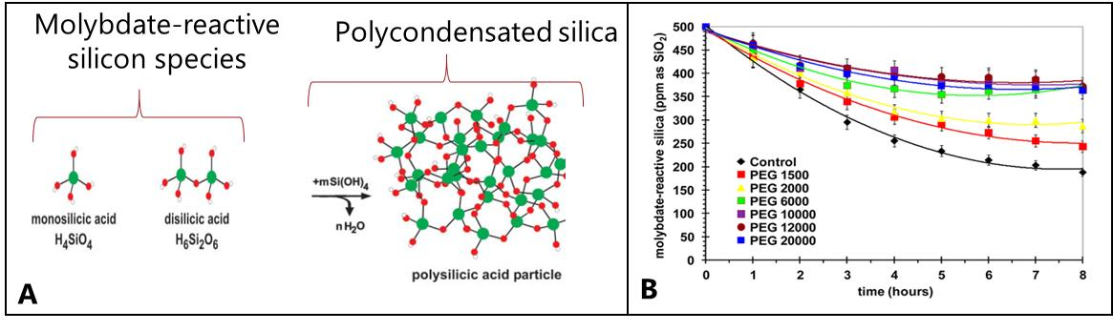

**Fig 1**. A. In some plants monomers and dimers of silicic acid polycondensate to produce silica. This reaction can be followed in-vitro with a standard spectrophotometric method. B. Image from 10, showing the stabilization of molybdate-reactive silica by PEG polymers during the first 8 h of the condensation reaction.

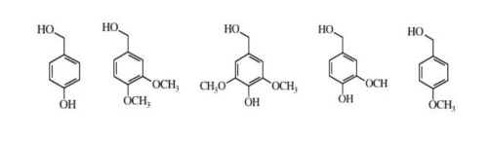Here, we are testing the **hypothesis** that lignin or lignin model compounds (i.e., uncharged phenolic biomacromolecules) are able to slow down the polymerization of silicic acid at a physiological relevant pH (6.8). Some hemicelluloses were also tested, since the capacity of interact with silica has been suggested before 6. In a previous experiment, using solid state NMR we showed that hydrogen bonds could be formed between lignin aliphatic hydroxyl or carboxyl groups and silanols 1, so, for this experiments we tested lignin model compounds with aliphatic hydroxyl groups.

## Experiments performed

Stock solutions of 1000 ppm Na2SiO3 were prepared using MiliQ water and plastic measuring flasks. Since these solutions have pH above 12, most of the silica species are soluble and measureable. The solutions were put in an ultrasonic bath for at least 5 min to ensure that the sodium metasilicate was completely dissolved. Linear calibration curves were prepared from the stock solution using the silicomolybdic blue acid method 25.

100 mL of 600 ppm Na2SiO3 in citric buffer (pH 6.8) was prepared by dissolution from the stock solutions, the pH was adjusted to 6.8 using 3 M HCl. An aliquot of 1 mL was taken either every 5 minutes for the first hour, and every hour for 6 hours, and every 24/30 hours. The aliquots were diluted 10 times to reach the concentration range of the silicomolybdic blue acid method, and the molibdate-reactive-silica was measured.

The results for the control experiments were similar to results reported in the literature (Fig 2). We were able to track the polycondensation reaction in different time scales. As an additional control, we followed the polycondensation of solutions containing PEG 6000 and 10000, and got similar results as reported by Preari et al., 2014 10, confirming that our test set-up was able to detect changes in the polycondensation rates.

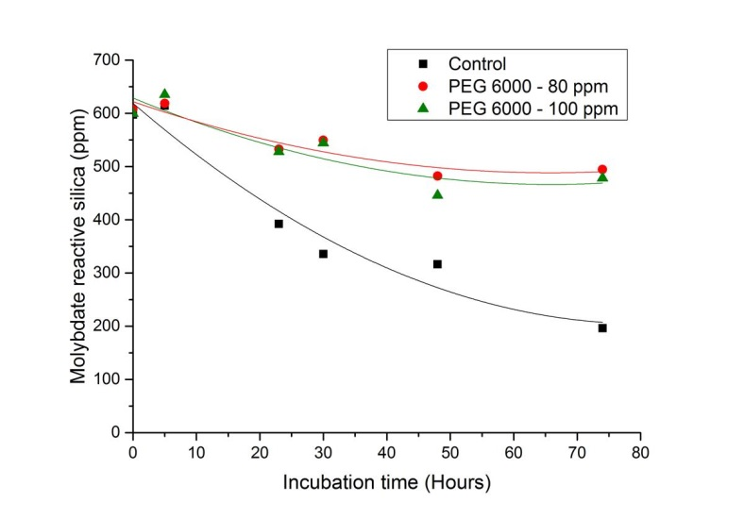

Fig 2. Example of an experiment done to track the polycondensation of silicic acid from 600 ppm Na2SiO3 solutions in citric buffer (pH 6.8)

We opted for measuring the reaction in a time scale of days. There were two reasons for this: (1) the rate of the polycondensation reaction for the control experiments seemed to decrease at around 50 hours, and (2) the poly hydrodynamic ratio of the silica particles increased in a time scale of days as determined by Dynamic Light Scattering (DLS) (Fig 3). The latter experiments were done with help of Professor Lars Øgendal at the Niels Bohr Institute, University of Copenhagen.

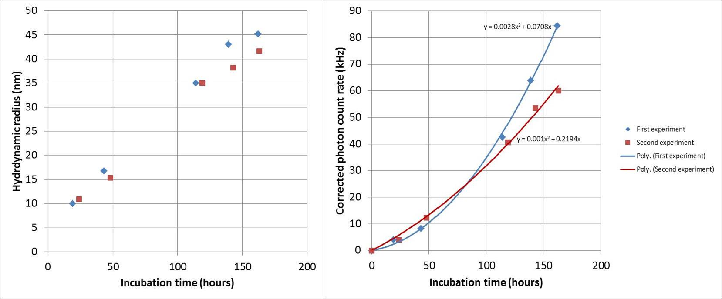

Fig 3. Example of two experiments done to track the polycondensation of silicic acid from 600 ppm Na2SiO3 solutions in citric buffer (pH 6.8) using DLS.

## Tested solutions

When lignin, lignin model compounds, or hemicelluloses were added to the buffered solution, none of the compounds (Table 1) were able to modify the kinetics measurements.

|  |  |  |
| --- | --- | --- |
| **Description** | **Chemical name** | **Tested concentrations** |
| Lignin model compounds | 2-Methoxy-4-methylphenol | 300, 600, 3000, 6000 ppm |
| Veratrol | 300, 600, 3000, 6000 ppm |
| 3,4-Dimethoxybenzyl alcohol | 300, 600, 3000, 6000 ppm |
| 3,5-dimethoxy-4-Hydroxyacetophenone | 819 ppm |
| 4-hydroxy-3-methoxybenzaldehyd | 1380 ppm |
| 2-methoxyphenol | 300, 600, 3000, 6000 ppm |
| Lignin | Soluble protobind lignin pH=6.8 | 0.5, 1, 2 g/L |
| Hemicelluloses | B-D-Glucan | 1111, 10000 ppm |
|  | D-Cellobiose | 1190 ppm |
|  | Gastrodignin | 1639 ppm |
| Controls | PEG 6000 | 32, 40 ppm |
|  | PEG 10000 | 32, 40 ppm |

Table 1. Compounds added to 600 ppm Na2SiO3 solutionss in citric buffer (pH 6.8) to see if they affect the polycondensation of silicic acid. Each compound and concentration was tested by separate experiments.

## Conclusion

In this study, we examined if lignin or lignin model compounds (i.e., uncharged phenolic biomacromolecules) are able to slow down the polymerization of silicic acid at a physiological relevant pH (6.8). None of the tested compounds were able to modify the polymerization rate.

## References

1. Cabrera, Y., Cabrera, A., Larsen, F. H. & Felby, C. Solid-state 29Si NMR and FTIR analyses of lignin-silica coprecipitates. *Holzforschung* **2016**, (2016).

2. Epstein, E. The anomaly of silicon in plant biology. *Proc Natl Acad Sci USA* **91**, (1994).

3. Kumar, S., Soukup, M. & Elbaum, R. Silicification in Grasses: Variation between Different Cell Types. *Frontiers in Plant Science* **8**, 438 (2017).

4. Głazowska, S., Murozuka, E., Persson, D. P., Castro, P. H. & Schjoerring, J. K. Silicon affects seed development and leaf macrohair formation in Brachypodium distachyon. *Physiologia Plantarum* **163**, 231–246 (2018).

5. Casey, W., Kinrade, S., Knight, C., Rains, D. & Epstein, E. Aqueous silicate complexes in wheat, Triticum aestivum L. *Plant, Cell & Environment* **27**, 51–54 (2004).

6. Law, C. & Exley, C. New insight into silica deposition in horsetail (Equisetum arvense). *BMC Plant Biology* **11**, 1–9 (2011).

7. Brugiére, T. & Exley, C. Callose-associated silica deposition in Arabidopsis. *Journal of Trace Elements in Medicine and Biology* **39**, 86–90 (2017).

8. Trembath-Reichert, E., Wilson, J. P., McGlynn, S. E. & Fischer, W. W. Four hundred million years of silica biomineralization in land plants. *Proceedings of the National Academy of Sciences* **112**, 5449–5454 (2015).

9. Yamanaka, S. *et al.* Roles of silica and lignin in horsetail (Equisetum hyemale), with special reference to mechanical properties. *Journal of Applied Physics* **111**, 044703 (2012).

10. Fang, J.-Y. & Ma, X.-L. In vitro simulation studies of silica deposition induced by lignin from rice. *Journal of Zhejiang University. Science. B* **7**, 267–271 (2006).

11. Zhang, C., Wang, L., Zhang, W. & Zhang, F. Do lignification and silicification of the cell wall precede silicon deposition in the silica cell of the rice (Oryza sativa L.) leaf epidermis? *Plant and soil* **372**, 137–149 (2013).

12. Zhang, J. *et al.* Silica distinctively affects cell wall features and lignocellulosic saccharification with large enhancement on biomass production in rice. *Plant Science* **239**, 84–91 (2015).

13. Lapierre, C., Voxeur, A., Karlen, S. D., Helm, R. F. & Ralph, J. Evaluation of Feruloylated and p-Coumaroylated Arabinosyl Units in Grass Arabinoxylans by Acidolysis in Dioxane/Methanol. *J. Agric. Food Chem.* **66**, 5418–5424 (2018).

14. Rafi, M. M. & Epstein, E. Silicon absorption by wheat (Triticum aestivum L.). *Plant and Soil* **211**, 223–230 (1999).

15. Swedlund, P. J., Miskelly, G. M. & McQuillan, A. J. An attenuated total reflectance IR study of silicic acid adsorbed onto a ferric oxyhydroxide surface. *Geochimica et Cosmochimica Acta* **73**, 4199–4214 (2009).

16. Mansfield, S. D., Kim, H., Lu, F. & Ralph, J. Whole plant cell wall characterization using solution-state 2D NMR. *Nat. Protocols* **7**, 1579–1589 (2012).

17. Sluiter, A. *et al.* Determination of structural carbohydrates and lignin in biomass. *Laboratory analytical procedure* **1617**, 1–16 (2008).

18. Inanaga, S., Okasaka, A. & Tanaka, S. Does silicon exist in association with organic compounds in rice plant? *Soil Science and Plant Nutrition* **41**, 111–117 (1995).

19. Fleck, A. T. *et al.* Silicon enhances suberization and lignification in roots of rice (Oryza sativa). *Journal of Experimental Botany* **62**, 2001–2011 (2011).

20. Perry, C. C. & Lu, Y. Preparation of silicas from silicon complexes: Role of cellulose in polymerisation and aggregation control. *J Chem Soc Faraday Trans* **88**, (1992).

21. Kroger, N., Sumper, M. & Baeuerlein, E. 9 The Molecular Basis of Diatom Biosilica Formation. *Biomineralization: Progress in biology, molecular biology and application* 135–158 (2004).

22. Preari, M., Spinde, K., Lazic, J., Brunner, E. & Demadis, K. D. Bioinspired Insights into Silicic Acid Stabilization Mechanisms: The Dominant Role of Polyethylene Glycol-Induced Hydrogen Bonding. *J. Am. Chem. Soc.* **136**, 4236–4244 (2014).

23. Spinde, K. *et al.* Influence of Polyamines and Related Macromolecules on Silicic Acid Polycondensation: Relevance to “Soluble Silicon Pools”? *Chem. Mater.* **23**, 4676–4687 (2011).

24. Exley, C. A possible mechanism of biological silicification in plants. *Frontiers in plant science* **6**, (2015).

25. Coradin, T., Eglin, D. & Livage, J. The silicomolybdic acid spectrophotometric method and its application to silicate/biopolymer interaction studies. *Journal of Spectroscopy* **18**, 567–576 (2004).